**Phys 11A – Eiteneer**

**Lab 11 Write-up**

**Names: ____________________**

**Introduction:** The last scheduled lab for the semester is the angular momentum lab. This lab consists of a puck sliding on a home-built air hockey table while tied at its center of mass to a central peg with an extendable rubber band, as described in the lab manual. As the puck moves, it changes its distance from the peg and its linear velocity; however, with virtually no friction, and as the rubber band exerts a central force on the puck, the angular momentum should be conserved, as no net torque is exerted on the puck. Our job is to confirm this.

*Please answer the following questions. The answers can be hand-written or typed.*

1. In two or three sentences, explain how this experiment is conducted. As in, summarize the procedure.
2. Why do we not care about the “details” of the force exerted by the rubber band?
3. In your own words, summarize/explain the meaning of conservation of angular momentum. No equations!
4. What are the “convenience units” of mass, time, length, and angle, used in this lab? Note: do not make any conversions of units in this lab.
5. What are the units of angular momentum, in these “convenience units”?
6. Fill in the Excel table provided to you by the instructor. You need to measure the distance from the center of the trajectory to the center of the puck for all 16 positions (r_t, measured in grid-inches), and the angle for all 16 positions (φ, measured in degrees). The Excel calculations are already done for you (15 calculations since calculations of r and Ω require the next value as well). The units of Ω have also been converted to rad/flash, so you don’t have to worry about that.
7. Think about the uncertainty in measuring r_t and φ, and fill in the uncertainty table, also provided in Excel.
8. Derive the equation for uncertainty in angular momentum, δL, using the error propagation technique. Remember, 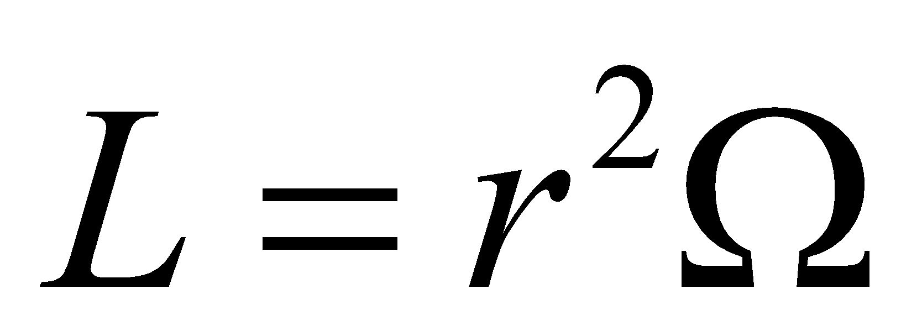, and that uncertainty 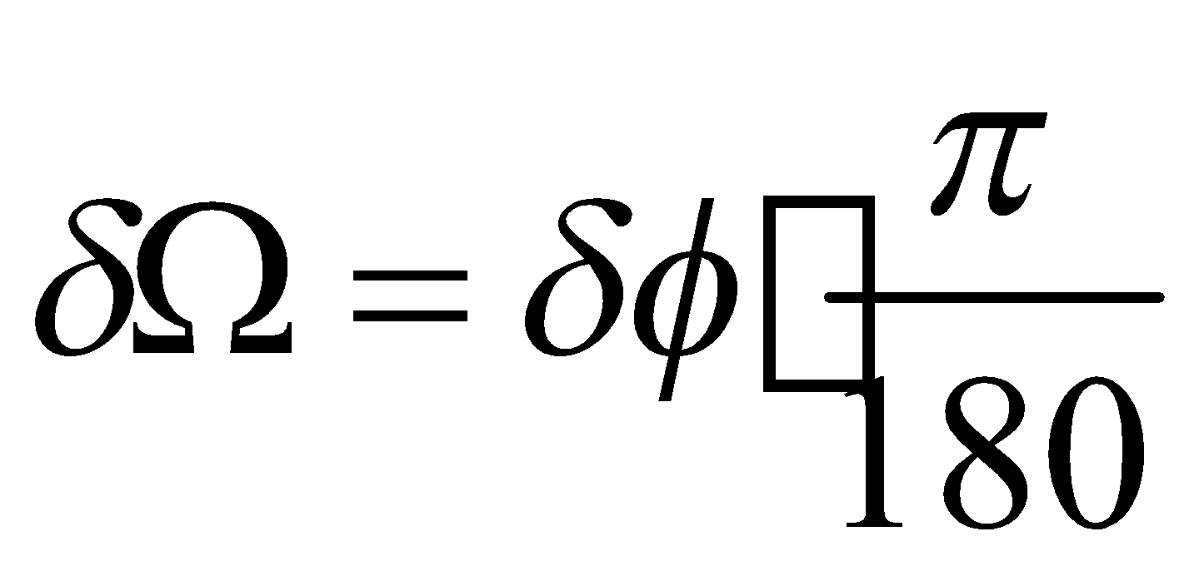. Assume that the mass of the puck (= 1 puck) is exact, and the time between flashes (= 1 flash) is exact.
9. Calculate the average value of angular momentum L, and the average value of uncertainty, δL (use Excel). Record the final answer here (don’t forget units):

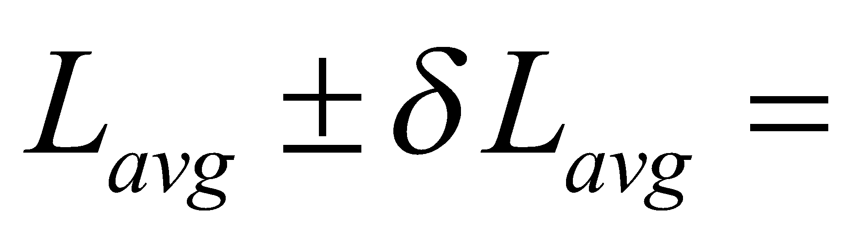

1. Is total angular momentum conserved during the experiment (use your data to answer this)? Why or why not?
2. Where is the puck moving the fastest? The slowest?
3. Pick any two adjacent puck positions, and draw a line connecting the centers. Also draw a two lines, one from each puck position, to the center of the trajectory, thus completing a triangle. Repeat for another two puck positions, at least two or three positions away.
4. Using a ruler, measure the sides of each of the three triangles in cm, and calculate the two areas (in cm2), using Heron’s formula (provided in the lab manual). Show work!
5. Are these two areas the same? Why or why not? Should they be?
6. What could contribute to the errors? List at least 2 or 3 sources of error, specifying whether each of them contributes to random error or systematic error. Note: no credit will be given for listing “human error.”

**What to submit:**

* Your data tables (Excel)
* Your drawing of the two triangles for Question 13
* Your answers to these questions
* Put all your tables, your drawing and answers to these questions in ONE document. Convert this document to PDF form, and submit INDIVIDUALLY, by going to Assignments, Lab 01.
* This will be due at 6pm ONE week from today.